GASES
LET’S GET STARTED
1)What are the physical states of matter? Give examples of substances in each state and describe their properties.
2)Describe the shape and volume of matter in each of the physical states. Are they fixed or can they vary for the same amount of matter?
3)What gases do you know? How can you detect their presence?

WORK WITH THE IMAGE
Look at the photos below
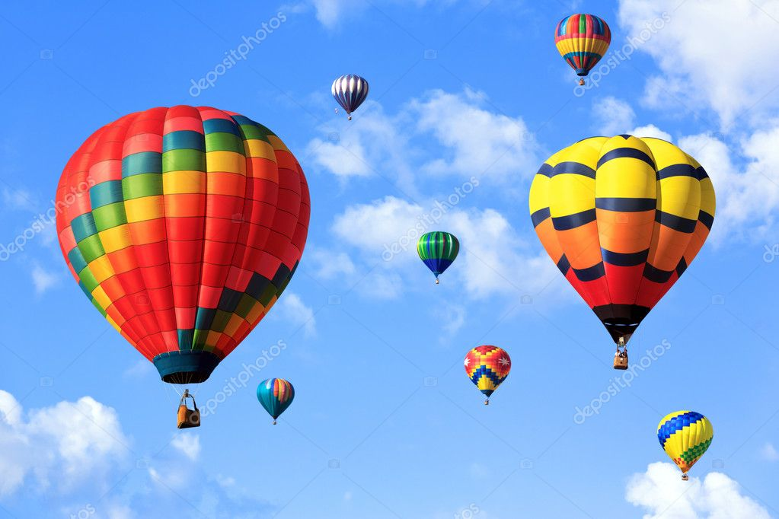

4)What properties of the atmosphere can you measure from a hot-air balloon?
5) A weather balloon, or sounding balloon, is a hot-air balloon that can reach high altitudes. What are the advantages of taking measurements from a weather balloon?

Look at the photos below




6) When we inflate a balloon, the air we blow into it exerts a pressure that changes the shape of the balloon. What can happen if the balloon is inflated too much?

7) When we inflate a bicycle tyre, there is a moment when its shape becomes fixed. It stops increasing its size, even though we continue to blow air into it. We notice that the tyre becomes harder. What is happening with the air inside the tyre?

